Janis Gonzalez

WEB 335 Introduction to NoSQL

Exercise 4.3 MongoDB Shell

April 09,2023

Bellevue University

1.

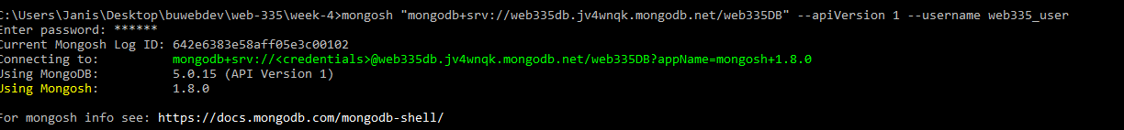



2.

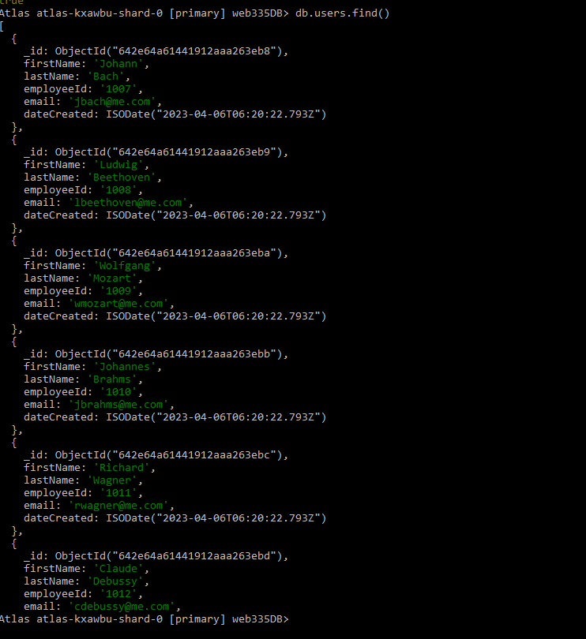

3.

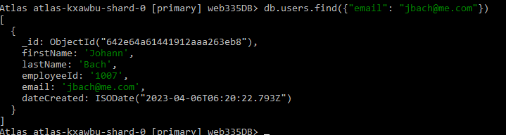

4.

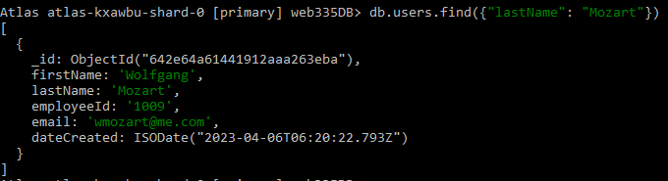

5.

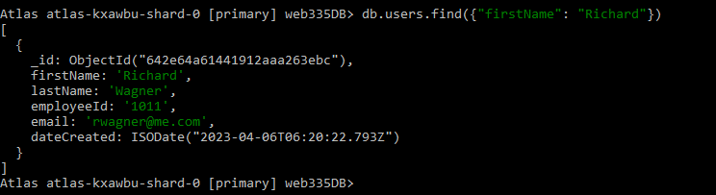

6.

